**Project Name:**

CMS (Campus Management System)

1. **Problem and Solution:**
   1. **Problem:**
      1. Teachers have to mark the attendance on registers which causes mistakes and students suffer because of those mistakes and strict policies of the University.
      2. Teachers have to manage grades manually which also causes mistakes sometimes and students suffer.
      3. Students have to enroll and withdraw subjects manually and mishaps occur with applications many times.
      4. All the records are kept in registers by staff of respective departments which is a very tough task.
      5. Library staff feels much difficulty to manage and record all check in and check outs of books manually and many books have been lost.
   2. **Solution:**
      1. The solution to all the above problems is to make an automated and online campus management system (CMS).
      2. The teachers will be able to mark attendance online and students will be able to check it and get a text message if they have been marked absent.
      3. Teachers will mark and upload the grades on CMS and students can check their grades and ask the teacher if they are not correct.
      4. Online Enrollment and Withdrawal applications will be available for students.
      5. All library record will be kept on CMS and staff and users will be able to check the status and fines etc.
2. **Vision Statement:**

For University students, teachers and staff members who want to manage attendance, grades, enrollments, withdrawals and library books check in and check out online. CMS (Campus Management System) is an online system having database of all the departments of a University and is accessible to all the departments of a University. Our product will provide easy access to student attendance, library staff and all the other departments associated with the University.

**NOTE:**

No **Unlike** part in vision statement because the application is considered to be the very first of its kind.

1. **Use Case Diagram:**

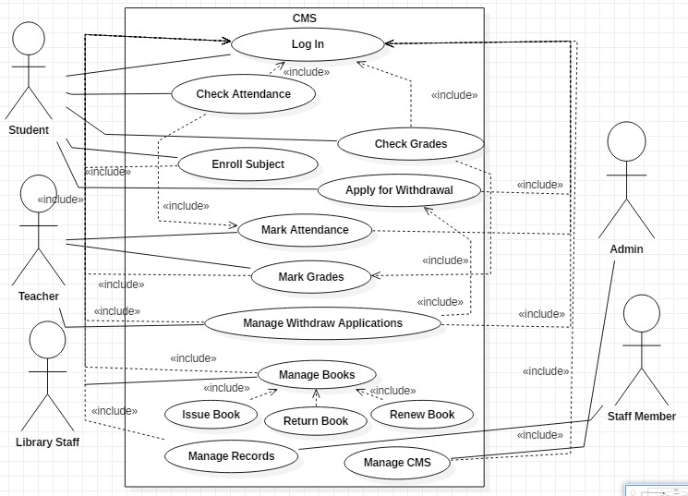

1. **Use Cases:**
   1. **UC1 [Fully Dressed]:**

**Name:** Enroll Subject

**Primary Actor:** Student

**Scope:** CMS (Campus Management System)

**Level:**  User Goal

**Stakeholders and Interest:**

-Student: Wants to enroll in a subject Successfully.

**Pre-Conditions:**

User has logged into the CMS.

The System has verified the identity of user.

**Post- Conditions:**

User is successfully enrolled in a subject.

Records are updated in database.

**Main Success Scenario:**

1. Student enters ID and password to log into CMS.
2. The system verifies and authenticates the student.
3. Student enters the subject code.
4. Student confirms enrollment.
5. The system checks if pre-req subjects are passed or not.
6. Student record is updated in database.
7. System repeats iii-vi until student indicates done.

**Extensions (Or Alternative Flows):**

1. The system verifies and authenticates the student.

**2a.** Student enters incorrect ID or password.

**2a1.** The system asks to enter ID or password again.

**3.** Student enters the subject code.

**3a.** Student enters incorrect subject code.

**3a1.** The System asks to re-enter the subject code.

**5.** The system checks if pre-req subjects are passed or not.

**5a.** The student has not passed the pre-req subjects.

**5a1.** The system shows failure message.

**Frequency of Occurrence:** Almost Continuous.

* 1. **UC2 [Fully Dressed]:**

**Name:** Manage Withdraw Applications

**Primary Actor:** Teacher

**Scope:** CMS (Campus Management System)

**Level:**  User Goal

**Stakeholders and Interest:**

-Student: Wants to withdraw in a subject Successfully.

-Teacher: Wants to approve or disapprove an application.

**Pre-Conditions:**

Teacher has logged into the CMS.

The System has verified the identity of teacher.

Student has applied for withdrawal.

**Post- Conditions:**

Teacher has successfully accepted or rejected the application.

**Main Success Scenario:**

1. User enters ID and password to log into CMS.
2. The system verifies and authenticates the user.
3. The user checks previous Mid term marks of students.
4. The user accepts or rejects the application.
5. Student record is updated in database.

**Extensions (Or Alternative Flows):**

1. The system verifies and authenticates the User.

**2a.** User enters incorrect ID or password.

**2a1.** The system asks to enter ID or password again.

**3.** The user checks previous Mid term marks of students.

**3a.** The total Mid Term marks are greater than 30.

**3a1.** The user rejects the application.

**3b.** The total Mid Term marks are less than 30.

**3b1.** The user accepts the application.

**Frequency of Occurrence:** Almost Continuous.

* 1. **UC3[Brief]:**

**Issue Book:**

* + 1. The user logs into his library CMS account.
    2. The user scans the barcode of book.
    3. The user enters the CMS ID of student.
    4. The system authenticates the student.
    5. The system checks if the checkout limit is exceeded.
    6. The system shows success or failure message.
    7. The system updates the database.
    8. The system repeats ii-vii until done.
  1. **UC4[Brief]:**

**Renew Book:**

* + 1. The user logs into his library CMS account.
    2. The user enters the CMS ID of student.
    3. The user selects the book to be returned.
    4. The user confirms to return the book.
    5. The database is updated.
  1. **UC5[Brief]:**

**Check Grades:**

* + 1. The user logs into his CMS account.
    2. The user selects the subject whose grades are to be checked.
    3. The user verifies the grades.
    4. The user complains in case of mistake.
    5. The system repeats ii-iv until done.